Mike McGoff

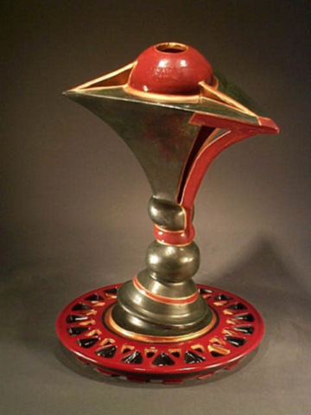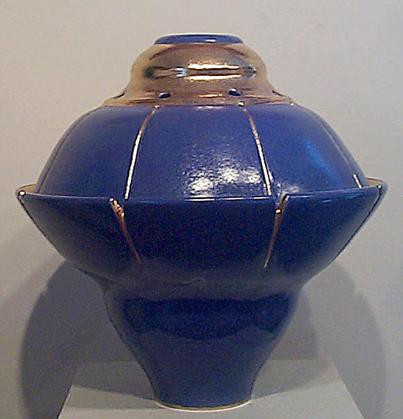
“Untitled” 16x16x22 $2,200 “Golden Blue” $2,500
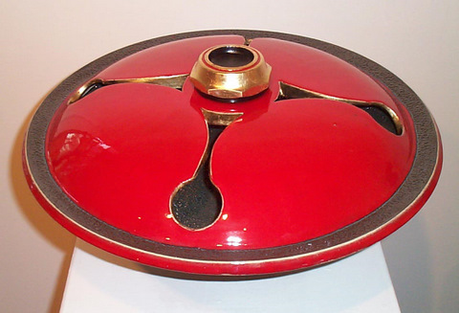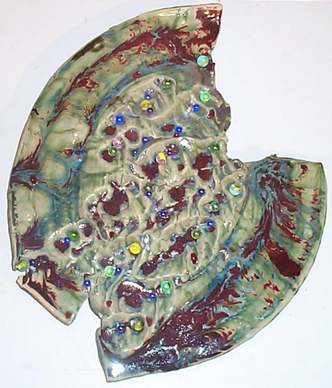
“Dome Bowl VIII” 18x18x11 $2,800 “Medalion” 18x21 $1,000

EDUCATION: Johnson College, Scranton, Pa. - Welding 2010
Marywood University, Scranton, PA
Bachelors of Fine Arts – Ceramics/Sculpture
Graduated - May 1986
Master of Fine Arts – Ceramics/Sculpture
Graduated – May 1989
SPECIAL
PROJECTS: Created and published website: www.creationstudiogallery.com

PUBLISHED
WORKS: SLOART Productions Direct Art Buyers Magazine, Vol. II,1999 & V,01
New Art International – 2002/03

PROFESSIONAL
EXPERIENCE:
10/11- Present Moscow Clay Works, Moscow, Pa - Instructor - Pottery Classes
12/10 – 04/11 Ronco Machine and Equipment, Lake Winola – Welder/Fabricator
11/02 to present Creations Studio Gallery, Moscow, PA
Job Title: Owner and Artist
Responsibilities: Create decorative and sculptural ceramics for
sale and display to the general public and by commission; consignments
accepted for other fine artists; design curriculum and teach classes to
children and adults.

11/05-7/09 Life Geisinger, Dunmore, Pa.
Job Title: Recreational Therapy Ass.
Responsibilities: Provide leisure and recreational activities for clients in an adult day care facility under the supervision of a Recreational Therapist. We provide a variety of leisure activities to assist our clients to remain vital and active in their later years.

9/90-11/05 Community Medical Center, Scranton, PA
Job Title: Activities Therapist
Responsibilities: Provide leisure and recreational activities for clients in
an Acute Care Psychiatric Unit: Arts and Crafts, Game groups, Music Group, Off Unit Activities, and Special Holiday Meals
2011 Moscow Clay Works, Moscow Pa. Ceramic Instructor
1997-02 Scranton Cultural Center, Scranton, PA
Ceramics Instructor
- Marywood University, Scranton, PA
3-D Design Instructor
1989 Wilkes College, Wilkes-Barre, PA
Ceramics Instructor
1989 Keystone College, La Plume, PA
Ceramics Instructor
1988/89 Marywood University, Scranton, PA
Ceramics Instructor

EXHIBITS: November First Fridat at AFA Gallery, 2011
Broderrik Gallery, Freehold, NY. 9/2011
Endless Mountains Arts Center, The Pastiche Exhibit Tunkhannock, Pa. 4/2010
Windsor Studio, First Friday Art Walk Exhibit, Scranton, PA. 3-6/2010
AFA Gallery Members Winter Exhibit, AFA Gallery, Scranton, Pa. 2/2010
AFA Gallery Auction, AFA Gallery Scranton Pa. 2009
Fine Art America, Web Gallery, 2009 - On Going
NEPA Regional Art 2008, Marywood Univ. Art Galleries, Scranton, Pa 2008
NEPA Clay Artists, AFA Gallery, Scranton, PA. 10/2007
Arts in Autumn 2, Creations Studio Gallery, Moscow, PA. 10/2007
Roberson Museum Regional Art Exhibit, Binghamton, NY. 7/14 to 9/15 2007
AFA Members Holiday Show, Scranton, PA. 2006/07
Arts in Autumn, Creations Studio Gallery, Moscow, PA. 10/2006
Professional Artists Invitational, Wilkes-Barre, PA, 05/2005
South Abington Center, Clarks Summit, PA. - 01/2005
Amsterdam Whitney Gallery, Chelsea, New York City – 2004
Art of the State, Pennsylvania State Museum, Harrisburg, PA – 6/04 - 10/04
Group Exhibit, SOHO Gallery, Scranton, PA – 4/03
The Art Bunch Exhibit, SOHO Gallery, Scranton, PA – 4/02
SOHO Gallery Presents, SOHO Gallery, Scranton, PA – 8/01
Artists as Visionaries, NEPA Regional Exhibit – 10/00
SOHO Gallery, Scranton, PA – 8/99
AFA Gallery, Scranton, PA – 1/99
Designer Crafts Gallery, Stroudsburg, PA – 6/98
Laura Craig Galleries, Scranton, PA – 1996/97
Artisans Market Place, Waverly, PA – 11/96
Pocono Crafts Fair (PA Guild of Craftsman ) Pocono, PA – 8/96
Everhart Museum Juried Art Exhibit, Scranton, PA – 10/96
Summer Art Exhibit, Hide Out Art Center, Hamlin, PA – 6/95
Everhart Museum Juried Art Exhibit, Scranton, PA – 8/94
AFA Sculptural Exhibit, Everhart Museum, Scranton, PA – 1992

COMMISSIONS: Benefit Plates in cooperation with Moscow Clay Works for The Everhart Museum, 2011
Hand Sculpted Tile Mural in cooperation with Moscow Clay Works, 2011
Custom Birdbath, 2008
Custom Sinks, 2007

RESTORATIONS: Blessed Mother Statue, 2005
Elf Statue, 2009
St. Anthony Statue 2012
Blessed Mother Statue 2012

