ON BECOMING A CRAFTSMAN by Frank Goryl

“It doesn’t happen all at once,” said the Skin Horse.
“You become. It takes a long time.”
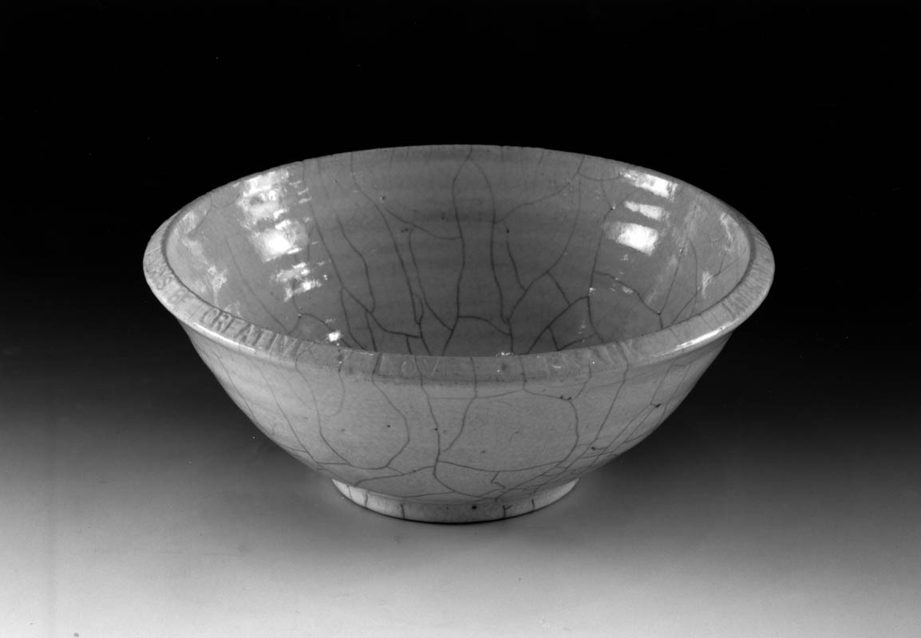
The Velveteen Rabbit

Ever since my drawing was selected for the 2nd grade Easter egg contest, I have always wanted to see myself and be viewed by others as an artist. I’ve always been pulled by the mystery of art, the idealized notion of a Bohemian lifestyle, the urge to remain in a creative mindset; and have always felt that the artist was beyond “matters of consequence” (Saint-Exupery, 1945 p. 46). I have continually returned to the arts after forays into other professions and a near death experience not necessarily made me believe that art saved my life but reinforced my desire to make a life and vocation in the arts.
Once introduced to the pottery studio, I have felt the need to shed my skin as an artist (or artist wanna be) in hopes of becoming a craftsman. A truth resonated with me when I read M.C. Richard’s (1964) comments that she found in craft a new birth of her ideals and felt her “center” become alive during her hours of silent practice in the studio. My heart found a home when I discovered Yanagi’s (1972) comments on the character of the craft being of more value than the personality of the artist. When I read Bergman’s (1960) statement that he made films in the same spirit as the collective and anonymous building of Chartes Cathedral, I gained clarity to the purpose of my work.
The pottery studio for me is a romantic place with its rich and earthy smells; its unique equipment and techniques; its magic alchemy and ritual of fire. The work of the studio can be labor intensive and requires hours if not days or years of dedication and commitment. The mixing of clay and glazes, wedging the clay body, the loading and unloading of the kiln become labors of love. The words of Speight (1989) “by responding to the clay’s plastic quality, you are repeating the actions of untold humans who have worked with clay as far back in time as the Ice Age” (p.3) remind me to listen to the stories and life’s lessons the studio has to offer.
Making bowls has taught me the acceptance of imperfection. It seems funny now that when I first attempted to master the potter’s wheel there was this insatiable desire to throw the “perfect” pot. Eliminating each technical defect seemed paramount. A flaw in the glaze or an asymmetrical shape is now a song I was once unable to hear. Countless times I have sat down at the wheel with the intent of making a quality work. I know I had the technical skills to make such an object yet the result would often be a heap of discarded clay on the wedging table.
Then there are the gifts. That joy and deep contentment of pulling a subtle curve or a clean and defining line in the clay. That genuine smile when raku has yielded a magnificent crackle. Upon throwing a quality bowl I am reminded of a Camille Saint-Saens quote, “I produce music as effortlessly as an apple tree produces apples” (Winner, 1982. p. 387).
Making bowls has taught me the difficult lesson regarding attachment. You know it is only an object but deep down inside there is the feeling that this bowl is like a child you have nurtured and loved from infancy. Although there is the possibility that the bowl will last until the next millennium. There is that all too common experience where it crumbles as greenware being loaded into the kiln, or judged unworthy and exploded by the kiln gods, or shattered when dropped while being passed to an admiring friend.
My work as a potter needs to remain simple. Without meaning. Without interpretation. Without metaphor. Beyond words if you will. My work needs to remain in that place where my literary heroes have tried to safeguard images. A place kept sacred in the sanctuary of soul.
The focus of my intent as I return to the pottery studio is to embrace Soetsu Yanagi’s (1972) definitions of craft: “good work proceeding from the whole man, heart, head and hand, in proper balance” (p.95). I am honored to share in the creative and transformative process and find comfort knowing that it’s going to take a lifetime to become a REAL craftsman.

REFERENCES

Bergman, I. (1960). Four screenplays. New York: Simon and Schuster.

Bianco, Margery Williams, (1965). The Velveteen Rabbit. Garden City, NY: Doubleday

Kramer, E. (1993). Art as therapy with children. (2nd ed.) Chicago: Magnolia Street Publishers

Richards, M.C. (1964). Centering. Middletown, CT: Wesleyan U. Press

Saint-Exupery, A. (1945). The Little Prince. London: Pan Books Ltd.

Slika, R. (2001). Clay into art. American Ceramics. 13(2), 44-46.

Speight, C. (1989). Hands in Clay. Mountain View, CA. Mayfield Publishing Co

Winner, E. (1982). Invented Worlds. Cambridge, MA: Harvard University Press.

Yanagi, S. (1972). The Unknown Craftsman. Tokyo: Kodansha International.

