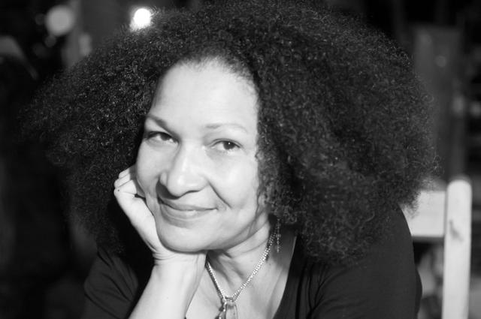

Lissa Jeannot

Lissa Jeannot was born in P ort of Prince March 28, 1958 and began working in clay at age 13 in a ceramics center in the city. After High School, Lissa studied ceramics at Escuela de Cerámica Jacinto Alcantara de la Moncloa, Madrid, Spain and also Instituto Statale d'Arte per la Ceramica, Sesto, Firenze, Italia. Following her studies, Lissa spent several years working as an artist in Spain before returning to Haiti. From 2004 to the present she has been the Artistic Director, Fondation le Mabouya, Cayes Jacmel, Haïti.

Her most recent exhibits include:
July 2013: Moscow Clayworks, Moscow, PA. USA
June 2011: Parade The Circle, Cleveland, Ohio.
April 2011: Danse Beauté, Petion-Ville, Haiti.
November 2010: Vibrations Caraïbes, Musée du Montparnasse, Paris, France.
November 2010: Ti Coup D'œil sur Haïti, Suresnes, France.
October 2011 : Moscow Clayworks. Moscow, PA. USA

